Question 1
Compute the simplified numeric value of subtracted from .

Question 2
Compute the whole number value of

Question 3
XYX and YXY represent two 3-digit whole numbers in which X and Y are distinct non- zero digits. Find the sum of the digits of the greatest possible sum of XYX and YXY.

Question 4
Mr. and Mrs. Hansen and their three children are to be seated about a circular table. In how many different ways can the family be seated if Mr. and Mrs. Hansen are seated next to one another?
Case 1 and 2 are not considered different (one is a rotation of the other). Case 3 is different from the first two cases.

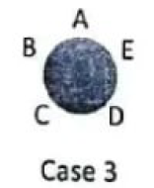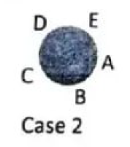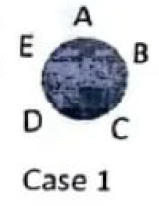



Question 5
Simplify:

Question 6
Let be the largest possible value of the fractiongiven thatis a positive integer factor of and y is a positive integer factor of 12. Find the value of .

Question 7
Let N be the greatest possible negative quotient when two distinct integers chosen from the set are divided. Find the value of .

Question 8
There are two prime numbers, P and Q, have the relationship that . How many possible values of are there?

Question 9
Starting at midnight, Aarf the Dog continues this bark-fest until 1:01 AM that same morning. How many times did Aarf the Dog bark for 15 seconds?

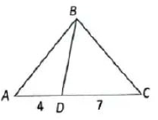
Question 10
Given with point on side such that and . If the area of is 20 square units, find the number of square units in the area of .

Question 11
How many points on the line segment with and have integer values for both coordinates and ?

Question 12
Computer the value of the expression below.

Question 13
Which is the greatest number of consecutive integers that sum to ?

Question 14
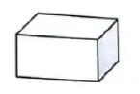
Three of the faces of a rectangular box have areas of ,and . What is the volume (in ) of the box?

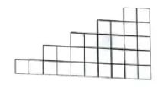
Question 15
Thirty squares unit are arranged, sharing common sides and vertices, in the “step” arrangement as shown. How many with integer length sides can be found in this arrangement?

Question 16
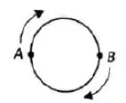
Andy and Brett begin at opposite points on a 300-foot circular track, and jog around the track in the directions shown. Andy jogs at 4.3 feet/sec and Brett jogs at 5.5 feet/sec. How many seconds will it take for Brett and Andy to meet for the first time?

Question 17
In the 5-digit integer XYYYX, X and Y represent different non-zero digits. If XYYYX is divisible by 11, how many different values of XYYYX are possible?

Question 18
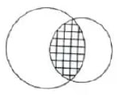
A circle of radius and a circle of radius overlap in the crosshatched region as shown. The area of the crosshatched region is . What is the half of the total area of the two regions without any crosshatching. (Use )

Question 19
Betsy collects sports posters, Exactly, one of the statements below is false.
Betsy has at least 6 sports posters.
Betsy has at least 15 sports posters.
Betsy has at least 19 sports posters.
Betsy has at least 23 sports posters.
What is the greatest possible number of posters in Betsy’s collection?

Question 20
XYX and YXY represent two 3-digit integers in which X and Y are distinct non-zero digits. How many different values are possible?

Question 21
Fins the greatest number that divides 256, 516 and 741 with same remainder in each case.

Question 22
Some 3-digit whole numbers have repeated digits. Two examples are 122 and 777. Exactly of all 3-digit whole numbers have repeated digits, where is a whole number. Find .

Question 23
How many fractions from the list below have decimal representation that terminate?

Question 24
A car is travelling on a road next to the train track at constant speed of . A train is 250 meters long and it travels the rear of the train, it takes the car M minutes to reach the front. Find M.

Question 25
The absolute value of N, symbolized by , represents the distance from the signed number N to the origin, without regard to sign. For example: and . Find the sum of the integer values of N that satisfy the inequality .

